Personal issues
Personal issues including family problems, life changing situations, emotional difficulties, illness, and even one's sexual orientation, can impact your job and ultimately your ability to advance your career. Try as you might to keep your private life separate from your work life, inevitably one may begin to run into the other. Learn how to keep personal issues from negatively affecting your job and career.

Work-Life balance
To get the right balance between work and lifestyle it’s important to set priorities. In this case happiness means to have as little separation between work and life. If that separation is too big, you would be overwhelmed. This could get you out of balance between work and life.

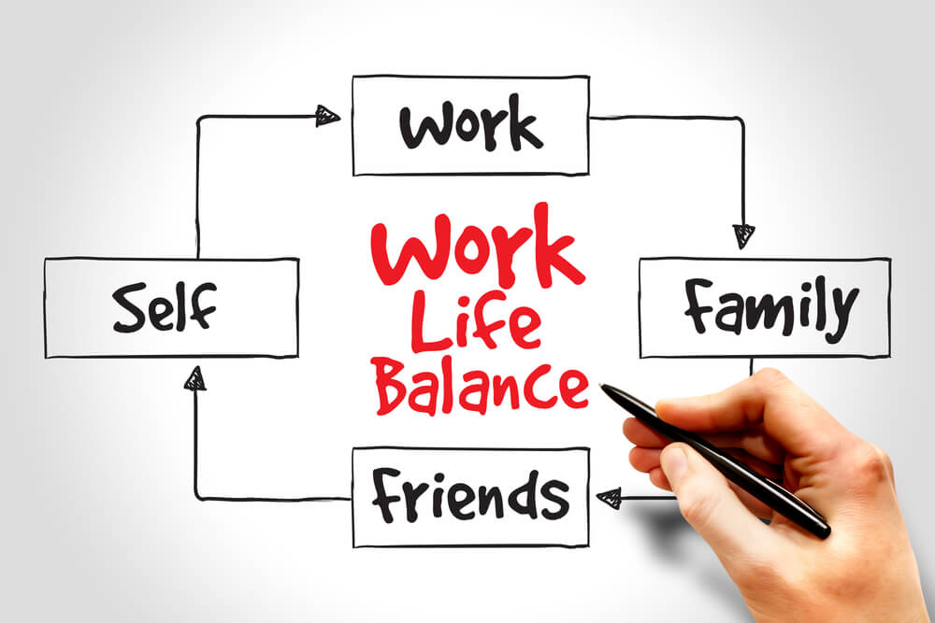

Career planning
Planning your career could be an ongoing process that can help you manage your learning and development. You can use this steps for school, work, projects or to improve your skills. It’s a process of thinking about your skills and interests. This is helpful to find what you want and make the right decisions. If you follow those steps you can reach your goals.

- Knowing yourself
Begin by thinking about where you are now, where you want to be and how you’re going to get there.

- Finding out
It’s about exploring the occupations and learning areas that interest you. Once you have some idea of your occupational preferences you can research the specific skills and qualifications required for those occupations.

- Making decisions
This step involves comparing your options, narrowing down your choices and thinking about what suits you best.

- Taking action
Here you plan the steps you need to take to put your plan into action.
Use all you have learnt about your skills, interests and values together with the information you have gathered about the world of work to create your plan.

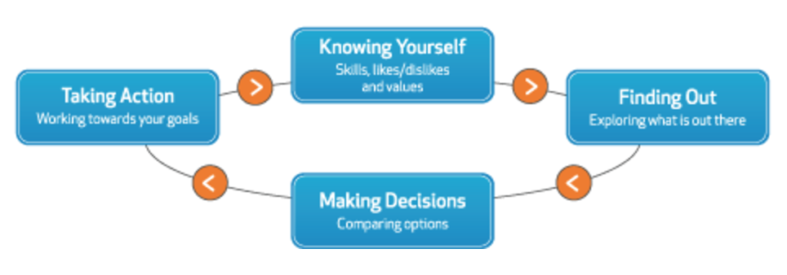

Education and further training
It’s important to have the right education for what you want to be. If you want to be programmer, you should have some it education. There are a lot of people who made wrong education decisions because they didn’t know what they want to be. So, if you follow the steps of career planning, you could also manage your education planning.
If you haven’t got skill in some parts you want to work, you a can always do a further training. There are further trainings in every job and those can help you a lot.

Sources
https://www.thebalance.com/how-to-deal-with-personal-issues-at-work-526107
http://www.careercentre.dtwd.wa.gov.au/CareerPlanning/Pages/CareerPlanning-4StepPlanningProcess.aspx

